**Day 54 - 56**

**What to do?**

So, you understood what is transfer learning. Now apply these architectures to your projects by directly applying it or fine-tuning it. Or do new projects.

**VGGNet:**

VGGNet is proven to be incredibly useful for image recognition purposes. Hence, CIFAR-10 dataset is used to classify the images using VGG-16 network.

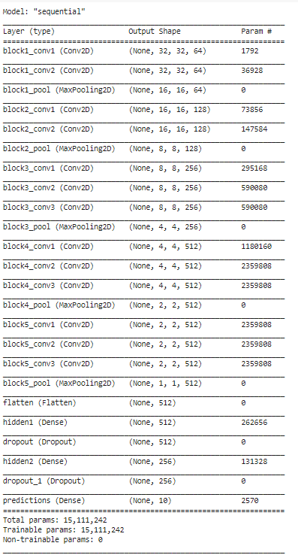

All the 16 layers are utilized from VGG-16 and “imagenet” pre-trained weights are used. Once the pre-trained weights are set, the model is then flattened and was connected to two fully connected layers of 512 and 256 neurons, respectively, with each layer having a dropout regularization of 0.4 each. The last output layer has 10 neurons with softmax activation function to predict the image classes.

The network is then compiled using SGD with learning rate of 0.001 and momentum of 0.9. The model is trained with 100 epochs and batch size of 128.

**Results:**

* Training loss: 0.1868; Training accuracy: 93.51%
* Val loss: 0.3781; Val accuracy: 88.91%
* Testing loss: 0.4016; Testing accuracy: 88.21%

The loss can get lower and accuracy can get better, if number of epochs may be increased or if image augmentation is applied.